Title or Task: | Title  

Description:

Files Required
Suitable for Classes: | All classes
Area: | Technology & Enterprise
Teacher: | Mr Peter Faulks

Timeline

Date Due:

Task Brief:

Outcomes:

Items highlighted in yellow are tasks for you to complete
Items in Blue italics are help tips

Lesson
Task Brief: How Computer Components Work
Computers work thanks to a series of hardware devices that are closely interconnected. When looking at a computer from the outside, the basic parts are the system case, which may be a tower for a desktop machine or the body of a laptop; the monitor; and the keyboard. A mouse or trackpad may or may not be essential to the functioning of a computer, depending on the type and model. Many computers also have a CD or other disc drive in the case.
Most of the essential things that make computers work are inside the case, away from your eyes. The motherboard is central point of the computer, where all the various components attach and communicate with each other. Key to allowing a computer to work is the central processing unit (CPU), the central stop for all the processes the computer goes through. As a command is sent, such as "open a program" or "turn the monitor on," the CPU interprets this order and then acts accordingly.
Once the computer is turned on, or booted up, the CPU goes on to activate certain sections so that it can then give you access to programs and processes. Computers work based on the CPU granting access to users, so if the booting up process malfunctions, it can mean that the computer cannot be used, even if everything else inside is working properly.
Memory is also extremely important to allow a computer to work. The two main kinds of memory are Random Access Memory (RAM) and Read-Only Memory (ROM). ROM is stored data, and cannot be written to; RAM is memory that can be read from and written to, allowing new data to be saved. In many cases, additional RAM can be added.
One kind of ROM is the Basic Input/Output System (BIOS), which is in charge of communications between the software on a computer and the hardware. When a computer is first turned on, the BIOS checks basic data such as hard memory, RAM, any cards installed, and other devices. BIOS also checks for booting up errors and offers to fix them if necessary.
Other less central — but no less vital — parts that let computers work include the power supply, transformer, and battery. These parts make sure each component gets the electricity it needs in the proper amount, and that key information is saved even when the power is off. The computer drives, including hard drives, flash drives, and any drives with removable media, such as CD-ROM drives, allow the user to upload new data and applications to the computer and save files. The cooling system helps keep all of the components from overheating.
Most computers also have other components without which a computer would be more difficult to use. Graphics cards allow the computer to display graphics on the monitor, and come in many different levels. Sounds cards allow the computer to play sounds. Connecting to the Internet or other computers requires a modem. Most computers come with all of these components, and often it is possible for the owner to upgrade each to newer or more advanced versions.
Input/output (I/O) is the name given to the processes or components needed to interact with the CPU and make computers work. These include the monitor and keyboard, but also CD-ROMs and removable flash memory cards. Input/output processes allow you to order the computer to do something, making the essential for interaction and use.
The Computer Brain

When you first turn on a typical computer, it must run an initial program that sets up the operating system. This initial program has to run even before the computer is able to interact with its hard drive, so the program must be available at the very instant the computer's power becomes available. Read-only memory is used for this initial bootup operation. Unlike normal random access memory, which is usually "volatile" and loses its stored information when power is removed, read-only memory retains its information without power. When you turn on the computer, this read-only memory provides the instructions the computer uses to begin loading the operating system from the hard drive.

A computer chip is also known as a digital integrated circuit. It is typically a thin wafer of silicon, cut from a single crystal of that element. The surface of the wafer has been chemically modified and it has had intricate patterns of aluminum wires and other structures cut and deposited photographically on its surface to form enormous numbers of transistors and other special structures. Each of these transistors is an electronically controllable switch. A tiny adjustment in the electric charge on the control element of one of these transistors—its gate—can dramatically alter that transistor's current carrying ability. These transistors work together to perform task that range from remembering one bit of information to multiplying two huge numbers together. The millions of transistors on a typical computer chip are able to perform extremely complicated tasks, as we see everyday in modern computers.
A digital computer's hardware is a complex system of four functionally different elements—a central processing unit, input devices, memory-storage devices, and output devices—linked by a communication network, or bus. The bus is usually incorporated into the main circuit board, called the motherboard, which is plugged into all the other components.
Bits
A computer chip is also known as a digital integrated circuit. It is typically a thin wafer of silicon, cut from a single crystal of that element. The surface of the wafer has been chemically modified and it has had intricate patterns of aluminum wires and other structures cut and deposited photographically on its surface to form enormous numbers of transistors and other special structures. Each of these transistors is an electronically controllable switch. A tiny adjustment in the electric charge on the control element of one of these transistors—its gate—can dramatically alter that transistor's current carrying ability. These transistors work together to perform task that range from remembering one bit of information to multiplying two huge numbers together. The millions of transistors on a typical computer chip are able to perform extremely complicated tasks, as we see everyday in modern computers.

How Big Is a Bit?
bit: The word "bit" is short for "binary digit." A bit is the smallest piece of computer information.
byte: Most computers use combinations of eight bits, called bytes, to represent one character of data. For example, the word "cat" has three characters, and it would be represented by three bytes.
kilobyte (K or KB): A kilobyte is equal to 1,024 bytes. megabyte (MB) A megabyte is equal to 1,048,576 bytes, but it is usually rounded off to one million bytes.
gigabyte (GB): A gigabyte is one thousand megabytes.
terabyte (TB): A terabyte is one trillion bytes, or 1000 gigabytes.
Computer memory is usually measured in megabytes or gigabytes. This tells how much information your computer can store.
The speed of a modem (a device that connects two computers over a telephone line) is measured in bits per second, or bps. This tells how much information can be sent in a second.
A computer generally works with groups of bits at a time. A group of eight bits is called a byte. A byte can represent the 256 different binary values 00000000 through 11111111, which are equal to the decimal values 0 through 255. That is enough values to assign a numeric code to each letter of the Latin alphabet (both upper and lower case, plus some accented letters), the 10 decimal digits, punctuation marks, and common mathematical and other special symbols. Therefore, depending on a program's context, the binary value 01000001 can represent the decimal value 65, the capital letter A, or an instruction to the computer to move data from one place to another.
The amount of data that can be stored in a computer's memory or on a disk is referred to in terms of numbers of bytes. Computers can store billions of bytes in their memory, and a modern disk can hold tens, or even hundreds, of billions of bytes of data. To deal with such large numbers, the abbreviations K, M, and G (for “kilo,” “mega,” and “giga,” respectively) are often used. K stands for 210 (1,024, or about a thousand), M stands for 220 (1,048,576, or about a million), and G stands for 230 (1,073,741,824, or about a billion). The abbreviation B stands for byte, and b for bit. So a computer that has a 256 MB (megabyte) memory can hold about 256 million characters. An 80 GB (gigabyte) disk stores about 80 billion characters.

Keyboard Basics
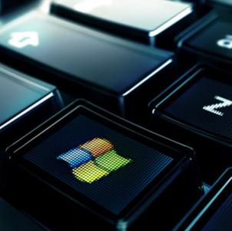
Photo courtesy www.artlebedev.com
Keyboards differ by manufacturer and the operating system they are designed for.
A keyboard's primary function is to act as an input device. Using a keyboard, a person can type a document, use keystroke shortcuts, access menus, play games and perform a variety of other tasks. Keyboards can have different keys depending on the manufacturer, the operating system they're designed for, and whether they are attached to a desktop computer or part of a laptop. But for the most part, these keys, also called keycaps, are the same size and shape from keyboard to keyboard. They're also placed at a similar distance from one another in a similar pattern, no matter what language or alphabet the keys represent.
Most keyboards have between 80 and 110 keys, including:
Typing keys
A numeric keypad
Function keys
Control keys
The typing keys include the letters of the alphabet, generally laid out in the same pattern used for typewriters. According to legend, this layout, known as QWERTY for its first six letters, helped keep mechanical typewriters' metal arms from colliding and jamming as people typed. Some people question this story -- whether it's true or not, the QWERTY pattern had long been a standard by the time computer keyboards came around.
Keyboards can also use a variety of other typing key arrangements. The most widely known is Dvorak, named for its creator, August Dvorak. The Dvorak layout places all of the vowels on the left side of the keyboard and the most common consonants on the right. The most commonly used letters are all found along the home row. The home row is the main row where you place your fingers when you begin typing. People who prefer the Dvorak layout say it increases their typing speed and reduces fatigue. Other layouts include ABCDE, XPeRT, QWERTZ and AZERTY. Each is named for the first keys in the pattern. The QWERTZ and AZERTY arrangements are commonly used in Europe.
The numeric keypad is a more recent addition to the computer keyboard. As the use of computers in business environments increased, so did the need for speedy data entry. Since a large part of the data was numbers, a set of 17 keys, arranged in the same configuration found on adding machines and calculators, was added to the keyboard.
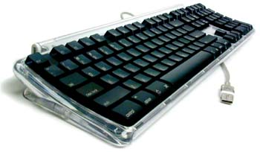
The Apple keyboard's control keys include the "Command" key.
In 1986, IBM further extended the basic keyboard with the addition of function and control keys. Applications and operating systems can assign specific commands to the function keys. Control keys provide cursor and screen control. Four arrow keys arranged in an inverted T formation between the typing keys and numeric keypad move the cursor on the screen in small increments.
Other common control keys include:
Home
End
Insert
Delete
Page Up
Page Down
Control (Ctrl)
Alternate (Alt)
Escape (Esc)
The Windows keyboard adds some extra control keys: two Windows or Start keys, and an Application key. Apple keyboards, on the other hand, have Command (also known as "Apple") keys. A keyboard developed for Linux users features Linux-specific hot keys, including one marked with "Tux" the penguin -- the Linux logo/mascot.
Inside the Keyboard
A keyboard is a lot like a miniature computer. It has its own processor and circuitry that carries information to and from that processor. A large part of this circuitry makes up the key matrix.
The microprocessor and controller circuitry of a keyboard
The key matrix is a grid of circuits underneath the keys. In all keyboards (except for capacitive models, which we'll discuss in the next section), each circuit is broken at a point below each key. When you press a key, it presses a switch, completing the circuit and allowing a tiny amount of current to flow through. The mechanical action of the switch causes some vibration, called bounce, which the processor filters out. If you press and hold a key, the processor recognizes it as the equivalent of pressing a key repeatedly.
When the processor finds a circuit that is closed, it compares the location of that circuit on the key matrix to the character map in its read-only memory (ROM). A character map is basically a comparison chart or lookup table. It tells the processor the position of each key in the matrix and what each keystroke or combination of keystrokes represents. For example, the character map lets the processor know that pressing the a key by itself corresponds to a small letter "a," but the Shift and a keys pressed together correspond to a capital "A."
The key matrix
A computer can also use separate character maps, overriding the one found in the keyboard. This can be useful if a person is typing in a language that uses letters that don't have English equivalents on a keyboard with English letters. People can also set their computers to interpret their keystrokes as though they were typing on a Dvorak keyboard even though their actual keys are arranged in a QWERTY layout. In addition, operating systems and applications have keyboard accessibility settings that let people change their keyboard's behavior to adapt to disabilities.
Keyboard Switches
Keyboards use a variety of switch technologies. Capacitive switches are considered to be non-mechanical because they do not physically complete a circuit like most other keyboard technologies. Instead, current constantly flows through all parts of the key matrix. Each key is spring-loaded and has a tiny plate attached to the bottom of it. When you press a key, it moves this plate closer to the plate below it. As the two plates move closer together, the amount of current flowing through the matrix changes. The processor detects the change and interprets it as a key press for that location. Capacitive switch keyboards are expensive, but they have a longer life than any other keyboard. Also, they do not have problems with bounce since the two surfaces never come into actual contact.
All of the other types of switches used in keyboards are mechanical in nature. Each provides a different level of audible and tactile response -- the sounds and sensations that typing creates. Mechanical key switches include:
Rubber dome
Membrane
Metal contact
Foam element
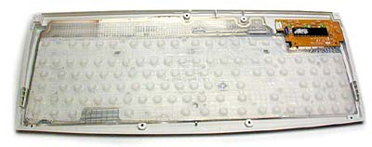
This keyboard uses rubber dome switches.
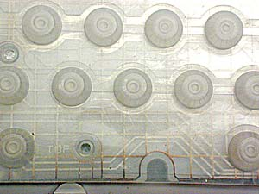
Rubber dome switches are very common. They use small, flexible rubber domes, each with a hard carbon center. When you press a key, a plunger on the bottom of the key pushes down against the dome, and the carbon center presses against a hard, flat surface beneath the key matrix. As long as the key is held, the carbon center completes the circuit. When the key is released, the rubber dome springs back to its original shape, forcing the key back up to its at-rest position. Rubber dome switch keyboards are inexpensive, have pretty good tactile response and are fairly resistant to spills and corrosion because of the rubber layer covering the key matrix.
Rather than having a switch for each key, membrane keyboards use a continuous membrane that stretches from one end to another. A pattern printed in the membrane completes the circuit when you press a key. Some membrane keyboards use a flat surface printed with representations of each key rather than keycaps. Membrane keyboards don't have good tactile response, and without additional mechanical components they don't make the clicking sound that some people like to hear when they're typing. However, they're generally inexpensive to make.
Metal contact and foam element keyboards are increasingly less common. Metal contact switches simply have a spring-loaded key with a strip of metal on the bottom of the plunger. When the key is pressed, the metal strip connects the two parts of the circuit. The foam element switch is basically the same design but with a small piece of spongy foam between the bottom of the plunger and the metal strip, providing a better tactile response. Both technologies have good tactile response, make satisfyingly audible "clicks," and are inexpensive to produce. The problem is that the contacts tend to wear out or corrode faster than on keyboards that use other technologies. Also, there is no barrier that prevents dust or liquids from coming in direct contact with the circuitry of the key matrix.
Different manufacturers have used these standard technologies, and a few others, to create a wide range of non-traditional keyboards. We'll take a look at some of these non-traditional keyboards in the next section.
Non-Traditional Keyboards
A lot of modifications to the traditional keyboard design are an attempt to make them safer or easier to use. For example, some people have associated increased keyboard use with repetitive stress injuries like carpal tunnel syndrome, although scientific studies have produced conflicting results. Ergonomic keyboard designs are intended to keep a person's hands in a more natural position while typing in an attempt to prevent injuries. While these keyboards can certainly keep people from holding their hands in a "praying mantis" position, studies disagree on whether they actually prevent injury.
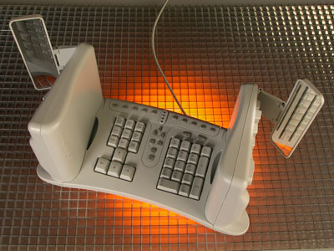
Photo courtesy www.safetype.com
The SafeType keyboard places the two halves of the keyboard perpendicular to the desk surface.
The simplest ergonomic keyboards look like traditional keyboards that have been divided down the middle, keeping a person's hands farther apart and aligning the wrists with the forearms. More complex designs place the two halves of the keyboard at varying angles to one another and to the surface on which the keyboard rests. Some go even further, placing the two halves of the keyboard on the armrests of chairs or making them completely perpendicular to the desk surface. Others, like the Datahand, don't look much like keyboards at all.
Photo courtesy www.saitek.com
Saitek Truview backlit keyboard buttons
Some modifications, while not necessarily ergonomic, are designed to make keyboards more portable, more versatile or just cooler:
Das Keyboard is a completely black keyboard with weighted keys that require more pressure from a person's strongest fingers and less pressure from the weaker ones.
The Virtual Laser Keyboard projects a representation of a keyboard onto a flat surface. When used successfully, a person's fingers pass through the beam of infrared light above the projected surface, and a sensor interprets it as a keystroke.
The True-touch Roll-up keyboard is flexible and can be rolled up to fit in a backpack or bag.
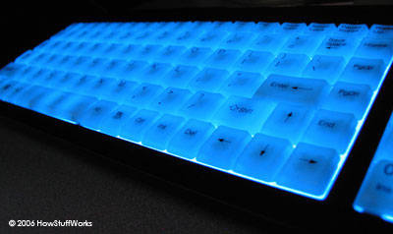
Blue backlit keyboard 'on'

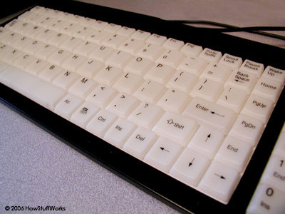
Blue backlit keyboard 'off'
Illuminated keyboards, like the Ion Illuminated Keyboard, use light-emitting diodes or electroluminescent film to send light through the keys or the spaces between keys.

Photo courtesy www.artlebedev.com
Optimus keyboard programmable hot keys
The Optimus keyboard has organic light-emitting diodes (OLEDs) in the keys. Users can change what letter, command or action each key represents, and the OLED can change to display the new information.
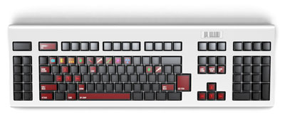
Photo courtesy www.artlebedev.com
This Optimus keyboard is set for keystrokes used to play Quake.
With the exception of the Virtual Laser Keyboard, which has its own sensing system, each of these keyboards uses the same type of technology as traditional models do to communicate with the computer. We'll look at that technology next.
From the Keyboard to the Computer
As you type, the processor in the keyboard analyzes the key matrix and determines what characters to send to the computer. It maintains these characters in its memory buffer and then sends the data.
A PS/2 type keyboard connector.
Many keyboards connect to the computer through a cable with a PS/2 or USB (Universal Serial Bus) connector. Laptops use internal connectors. Regardless of which type of connector is used, the cable must carry power to the keyboard, and it must carry signals from the keyboard back to the computer.
Wireless keyboards, on the other hand, connect to the computer through infrared (IR), radio frequency (RF) or Bluetooth connections. IR and RF connections are similar to what you'd find in a remote control. Regardless of which sort of signal they use, wireless keyboards require a receiver, either built in or plugged in to the USB port, to communicate with the computer. Since they don't have a physical connection to the computer, wireless keyboards have an AC power connection or use batteries for power.
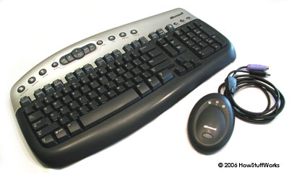
Microsoft wireless keyboard

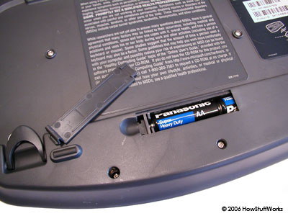
This Microsoft wireless keyboard is battery-powered.
Whether it's through a cable or wireless, the signal from the keyboard is monitored by the computer's keyboard controller. This is an integrated circuit (IC) that processes all of the data that comes from the keyboard and forwards it to the operating system. When the operating system (OS) is notified that there is data from the keyboard, it checks to see if the keyboard data is a system level command. A good example of this is Ctrl-Alt-Delete on a Windows computer, which reboots the system. Then, the OS passes the keyboard data on to the current application.
The application determines whether the keyboard data is a command, like
Alt-f, which opens the File menu in a Windows application. If the data is not a command, the application accepts it as content, which can be anything from typing a document to entering a URL to performing a calculation. If the current application does not accept keyboard data, it simply ignores the information. This whole process, from pressing the key to entering content into an application, happens almost instantaneously.

Random access memory (RAM) is the best known form of computer memory. RAM is considered "random access" because you can access any memory cell directly if you know the row and column that intersect at that cell.
The opposite of RAM is serial access memory (SAM). SAM stores data as a series of memory cells that can only be accessed sequentially (like a cassette tape). If the data is not in the current location, each memory cell is checked until the needed data is found. SAM works very well for memory buffers, where the data is normally stored in the order in which it will be used (a good example is the texture buffer memory on a video card). RAM data, on the other hand, can be accessed in any order.
Similar to a microprocessor, a memory chip is an integrated circuit (IC) made of millions of transistors and capacitors. In the most common form of computer memory, dynamic random access memory (DRAM), a transistor and a capacitor are paired to create a memory cell, which represents a single bit of data. The capacitor holds the bit of information -- a 0 or a 1 (see How Bits and Bytes Work for information on bits). The transistor acts as a switch that lets the control circuitry on the memory chip read the capacitor or change its state.
More on RAM
RAM Quiz
Does adding RAM make your computer faster?
PlanetGreen.com: Computer Tune Up
A capacitor is like a small bucket that is able to store electrons. To store a 1 in the memory cell, the bucket is filled with electrons. To store a 0, it is emptied. The problem with the capacitor's bucket is that it has a leak. In a matter of a few milliseconds a full bucket becomes empty. Therefore, for dynamic memory to work, either the CPU or the memory controller has to come along and recharge all of the capacitors holding a 1 before they discharge. To do this, the memory controller reads the memory and then writes it right back. This refresh operation happens automatically thousands of times per second.
http://computer.howstuffworks.com/inside-computer3.htm

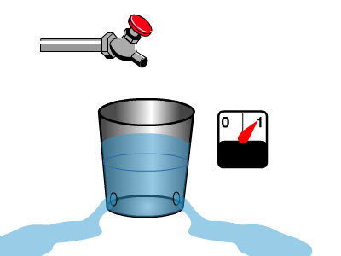
The capacitor in a dynamic RAM memory cell is like a leaky bucket.
It needs to be refreshed periodically or it will discharge to 0.
This refresh operation is where dynamic RAM gets its name. Dynamic RAM has to be dynamically refreshed all of the time or it forgets what it is holding. The downside of all of this refreshing is that it takes time and slows down the memory.
In this article, you'll learn all about what RAM is, what kind you should buy and how to install it. See the next page to learn more about dynamic RAM and memory cells.
Your Browser Does Not Support iFrames
Memory Cells and DRAM
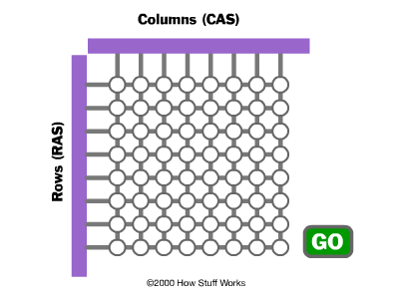
Memory is made up of bits arranged in a two-dimensional grid.
In this figure, red cells represent 1s and white cells represent 0s. In the animation, a column is selected and then rows are charged to write data into the specific column.
Memory cells are etched onto a silicon wafer in an array of columns (bitlines) and rows (wordlines). The intersection of a bitline and wordline constitutes the address of the memory cell.
DRAM works by sending a charge through the appropriate column (CAS) to activate the transistor at each bit in the column. When writing, the row lines contain the state the capacitor should take on. When reading, the sense-amplifier determines the level of charge in the capacitor. If it is more than 50 percent, it reads it as a 1; otherwise it reads it as a 0. The counter tracks the refresh sequence based on which rows have been accessed in what order. The length of time necessary to do all this is so short that it is expressed in nanoseconds (billionths of a second). A memory chip rating of 70ns means that it takes 70 nanoseconds to completely read and recharge each cell.
Memory cells alone would be worthless without some way to get information in and out of them. So the memory cells have a whole support infrastructure of other specialized circuits. These circuits perform functions such as:
Identifying each row and column (row address select and column address select)
Keeping track of the refresh sequence (counter)
Reading and restoring the signal from a cell (sense amplifier)
Telling a cell whether it should take a charge or not (write enable)
Other functions of the memory controller include a series of tasks that include identifying the type, speed and amount of memory and checking for errors.
Static RAM works differently from DRAM. We'll look at how in the next section.
http://computer.howstuffworks.com/ram1.htm

Graphics Processing Units
While we group graphics cards with the "guts" of a computer, some have their own microprocessors called a graphics processing unit (GPU). The GPU can handle some of the processing power required to generate rich graphics, which takes some of the load off the CPU.
The base of operations for the brains of a computer is the motherboard. The motherboard serves as a literal foundation for many of the other elements inside your computer. It's a large printed circuit board. The motherboard provides the connections and sockets that let other components communicate with each other. Motherboards come in different shapes and sizes -- a motherboard in a laptop computer might not look like one from a desktop PC.
The computer brain is a microprocessor called the central processing unit (CPU). The CPU is a chip containing millions of tiny transistors. It's the CPU's job to perform the calculations necessary to make the computer work -- the transistors in the CPU manipulate the data. You can think of a CPU as the decision maker.
This photo shows the RAM (upper left), the wireless card (bottom center) and the small battery (bottom right).
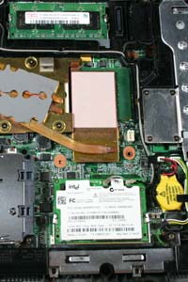
Another critical component in computers is memory. The two most important kinds of memory are read-only memory (ROM) and random access memory (RAM). Computers can read data stored in ROM, but can't write new data to it. With RAM, computers can read from and write to that memory. Without computer memory, every calculation on a computer would be stateless. That means there'd be no way to preserve information from one moment to the next and every process would start on a clean slate. That's not useful if you want to create complex programs.
Many desktop PCs have the capacity for additional RAM. The user simply has to open the computer and plug RAM chips into the appropriate sockets on the motherboard. But other computers are sealed systems -- you aren't meant to open them and make changes so you're pretty much stuck with what you've got.
A chip called the Basic Input/Output System (BIOS) works closely with the CPU. BIOS is a specific kind of ROM. If you think of the CPU as the brain of the computer, then you might consider BIOS to be the spine. It's the job of BIOS to handle interactions between the software running on a computer and the machine's hardware components.
The motherboard, CPU, ROM, RAM and BIOS handle most of the heavy lifting for computer processes. They're in charge of allocating resources to applications so that they run smoothly. They also accept input from devices like keyboards, mice and other computer accessories.

Go to the following site

http://computer.howstuffworks.com/hard-disk.htm
http://computer.howstuffworks.com/hard-disk.htm/printable

Label the parts of the Hard Disk Drive below at the end of the five pointers.
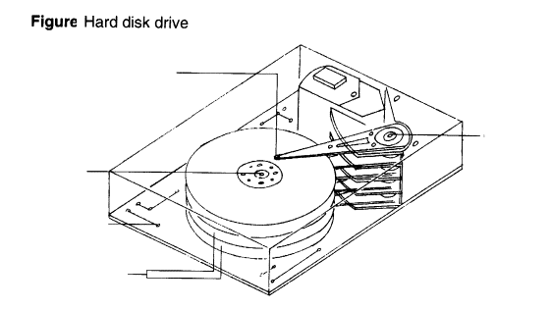

How the CD Rom Works
Look at the following sites

http://computer.howstuffworks.com/cd.htm http://computer.howstuffworks.com/cd.htm/printable
http://howthingswork.virginia.edu/

Label the following parts

Look at more computer components such as the Floppy Drive and label the parts

Explain the following in terms of a modern 9cm floppy disk and its drive.

Stepper Motor

Track

Sector

Block

Give the name for each of the following symbols in Logical Data Flow Diagrams

Understanding the CD: Material
As discussed in How Analog and Digital Recording Works, a CD can store up to 74 minutes of music, so the total amount of digital data that must be stored on a CD is:
44,100 samples/channel/second x 2 bytes/sample x 2 channels x 74 minutes x 60 seconds/minute = 783,216,000 bytes
To fit more than 783 megabytes (MB) onto a disc only 4.8 inches (12 cm) in diameter requires that the individual bytes be very small. By examining the physical construction of a CD, you can begin to understand just how small these bytes are.
A CD is a fairly simple piece of plastic, about four one-hundredths (4/100) of an inch (1.2 mm) thick. Most of a CD consists of an injection-molded piece of clear polycarbonate plastic. During manufacturing, this plastic is impressed with microscopic bumps arranged as a single, continuous, extremely long spiral track of data. We'll return to the bumps in a moment. Once the clear piece of polycarbonate is formed, a thin, reflective aluminum layer is sputtered onto the disc, covering the bumps. Then a thin acrylic layer is sprayed over the aluminum to protect it. The label is then printed onto the acrylic. A cross section of a complete CD (not to scale) looks like this:
Cross-section of a CD
Understanding the CD: The Spiral
A CD has a single spiral track of data, circling from the inside of the disc to the outside. The fact that the spiral track starts at the center means that the CD can be smaller than 4.8 inches (12 cm) if desired, and in fact there are now plastic baseball cards and business cards that you can put in a CD player. CD business cards hold about 2 MB of data before the size and shape of the card cuts off the spiral.
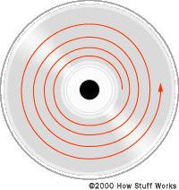
What the picture on the right does not even begin to impress upon you is how incredibly small the data track is -- it is approximately 0.5 microns wide, with 1.6 microns separating one track from the next. (A micron is a millionth of a meter.) And the bumps are even more miniscule...
Understanding the CD: Bumps
The elongated bumps that make up the track are each 0.5 microns wide, a minimum of 0.83 microns long and 125 nanometers high. (A nanometer is a billionth of a meter.) Looking through the polycarbonate layer at the bumps, they look something like this:
You will often read about "pits" on a CD instead of bumps. They appear as pits on the aluminum side, but on the side the laser reads from, they are bumps.
The incredibly small dimensions of the bumps make the spiral track on a CD extremely long. If you could lift the data track off a CD and stretch it out into a straight line, it would be 0.5 microns wide and almost 3.5 miles (5 km) long!
To read something this small you need an incredibly precise disc-reading mechanism. Let's take a look at that.
CD Player Components
The CD player has the job of finding and reading the data stored as bumps on the CD. Considering how small the bumps are, the CD player is an exceptionally precise piece of equipment. The drive consists of three fundamental components:
A drive motor spins the disc. This drive motor is precisely controlled to rotate between 200 and 500 rpm depending on which track is being read.
A laser and a lens system focus in on and read the bumps.
A tracking mechanism moves the laser assembly so that the laser's beam can follow the spiral track. The tracking system has to be able to move the laser at micron resolutions.
Inside a CD player
What the CD Player Does: Laser Focus
Inside the CD player, there is a good bit of computer technology involved in forming the data into understandable data blocks and sending them either to the DAC (in the case of an audio CD) or to the computer (in the case of a CD-ROM drive).
The fundamental job of the CD player is to focus the laser on the track of bumps. The laser beam passes through the polycarbonate layer, reflects off the aluminum layer and hits an opto-electronic device that detects changes in light. The bumps reflect light differently than the "lands" (the rest of the aluminum layer), and the opto-electronic sensor detects that change in reflectivity. The electronics in the drive interpret the changes in reflectivity in order to read the bits that make up the bytes.
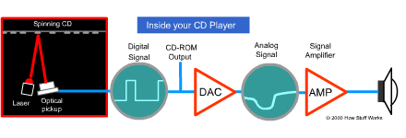
What the CD Player Does: Tracking
The hardest part is keeping the laser beam centered on the data track. This centering is the job of the tracking system. The tracking system, as it plays the CD, has to continually move the laser outward. As the laser moves outward from the center of the disc, the bumps move past the laser faster -- this happens because the linear, or tangential, speed of the bumps is equal to the radius times the speed at which the disc is revolving (rpm). Therefore, as the laser moves outward, the spindle motor must slow the speed of the CD. That way, the bumps travel past the laser at a constant speed, and the data comes off the disc at a constant rate.
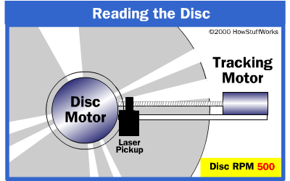

CD Encoding Issues
If you have a CD-R drive, and want to produce your own audio CDs or CD-ROMs, one of the great things you've got going in your favor is the fact that software can handle all the details for you. You can say to your software, "Please store these songs on this CD," or "Please store these data files on this CD-ROM," and the software will do the rest. Because of this, you don't need to know anything about CD data formatting to create your own CDs. However, CD data formatting is complex and interesting, so let's go into it anyway.
Photo courtesy Ernest von Rosen, AMGmedia
Recordable CD
To understand how data are stored on a CD, you need to understand all of the different conditions the designers of the data encoding methodology were trying to handle. Here is a fairly complete list:
Because the laser is tracking the spiral of data using the bumps, there cannot be extended gaps where there are no bumps in the data track. To solve this problem, data is encoded using EFM (eight-fourteen modulation). In EFM, 8-bit bytes are converted to 14 bits, and it is guaranteed by EFM that some of those bits will be 1s.
Because the laser wants to be able to move between songs, data needs to be encoded into the music telling the drive "where it is" on the disc. This problem is solved using what is known as subcode data. Subcode data can encode the absolute and relative position of the laser in the track, and can also encode such things as song titles.
Because the laser may misread a bump, there need to be error-correcting codes to handle single-bit errors. To solve this problem, extra data bits are added that allow the drive to detect single-bit errors and correct them.
Because a scratch or a speck on the CD might cause a whole packet of bytes to be misread (known as a burst error), the drive needs to be able to recover from such an event. This problem is solved by actually interleaving the data on the disc, so that it is stored non-sequentially around one of the disc's circuits. The drive actually reads data one revolution at a time, and un-interleaves the data in order to play it.
If a few bytes are misread in music, the worst thing that can happen is a little fuzz during playback. When data is stored on a CD, however, any data error is catastrophic. Therefore, additional error correction codes are used when storing data on a CD-ROM.
CD Data Formats
There are several different formats used to store data on a CD, some widely used and some long-forgotten. The two most common are CD-DA (audio) and CD-ROM (computer data).

Sound Basics
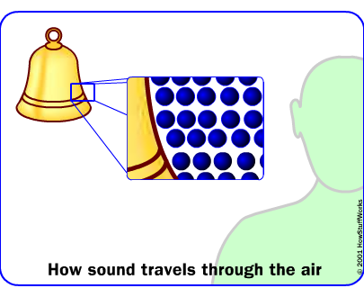
To understand how speakers work, you first need to understand how sound works.
Inside your ear is a very thin piece of skin called the eardrum. When your eardrum vibrates, your brain interprets the vibrations as sound -- that's how you hear. Rapid changes in air pressure are the most common thing to vibrate your eardrum.
An object produces sound when it vibrates in air (sound can also travel through liquids and solids, but air is the transmission medium when we listen to speakers). When something vibrates, it moves the air particles around it. Those air particles in turn move the air particles around them, carrying the pulse of the vibration through the air as a traveling disturbance.
To see how this works, let's look at a simple vibrating object -- a bell. When you ring a bell, the metal vibrates -- flexes in and out -- rapidly. When it flexes out on one side, it pushes out on the surrounding air particles on that side. These air particles then collide with the particles in front of them, which collide with the particles in front of them and so on. When the bell flexes away, it pulls in on these surrounding air particles, creating a drop in pressure that pulls in on more surrounding air particles, which creates another drop in pressure that pulls in particles that are even farther out and so on. This decreasing of pressure is called rarefaction.
In this way, a vibrating object sends a wave of pressure fluctuation through the atmosphere. When the fluctuation wave reaches your ear, it vibrates the eardrum back and forth. Our brain interprets this motion as sound.

Networks

Star Topology
All devices are connected to a central hub. Nodes communicate across the network by passing data through the hub.
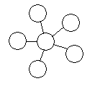
Bus Topology
All devices are connected to a central cable, called the bus or backbone.

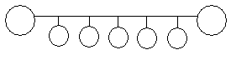
Ring Topology
All devices are connected to one another in the shape of a closed loop, so that each device is connected directly to two other devices, one on either side of it.

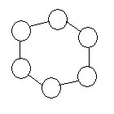

Label the parts of the Hard Disk Drive below at the end of the five pointers.

How the CD Rom Works
Give the name for each of the following symbols in Logical Data Flow Diagrams

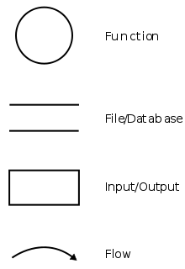

Bibliography
http://www.wisegeek.com/how-do-computers-work.htm
http://computer.howstuffworks.com/cd.htm http://computer.howstuffworks.com/cd.htm/printable
http://howthingswork.virginia.edu/
http://computer.howstuffworks.com/hard-disk.htm
http://computer.howstuffworks.com/hard-disk.htm/printable


Need help just ask

http://www.wisegeek.com/how-do-computers-work.htm

